

**VOCABULARY K-2**

|  |  |  |  |
| --- | --- | --- | --- |
| UNIT 9 YOU HAVE TO WASH YOUR HANDS | | | |
| 1 | cook | cocinar |  |
| 2 | get dressed | vestirse |  |
| 3 | wash my hands | lavar mis manos |  |
| 4 | clean | limpiar |  |
| 5 | wake up | despertar |  |
| 6 | brush | cepillar |  |
| 7 | wash the dishes | lavar los platos |  |
| 8 | yummy | delicioso |  |
| 9 | fun | divertido |  |
| 10 | toothpaste | pasta de dientes |  |
| 11 | toothbrush | cepillo de dientes |  |

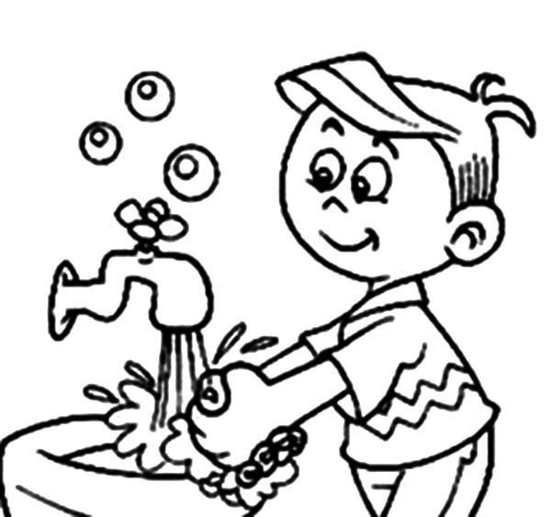

UNIT 9 YOU HAVE TO WASH YOUR HANDS