 

**VOCABULARY K-3**

|  |  |  |  |
| --- | --- | --- | --- |
| UNIT 8 I want to be a nurse | | | |
| 1 | doctor | doctor |  |
| 2 | nurse | enfermera |  |
| 3 | police officer | oficial de policia |  |
| 4 | firefighter | bombeo |  |
| 5 | farmer | granjero |  |
| 6 | vet | veterinario |  |
| 7 | teacher | maestro |  |
| 8 | uniform | uniforme |  |
| 9 | chef | cocinero |  |
| 10 | want | desear |  |
| 11 | help | ayuda |  |

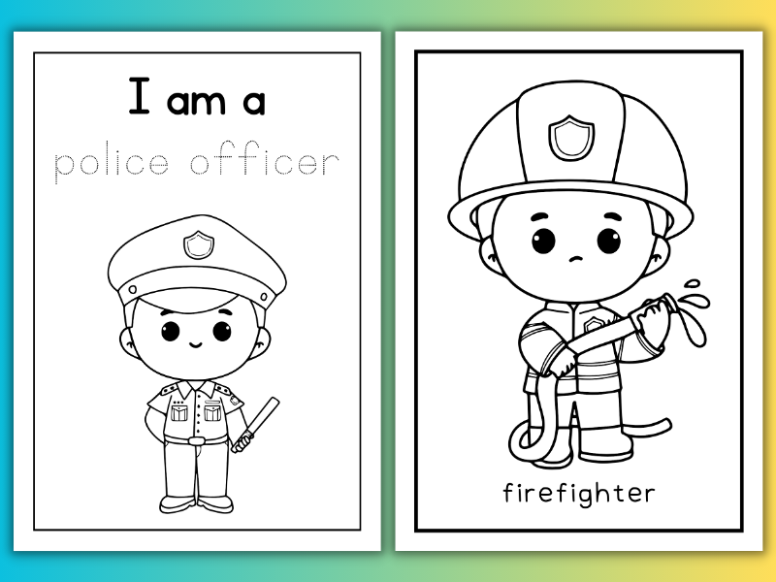

Unit 8 I want to be a …..