

**VOCABULARY K-3**

|  |  |  |  |
| --- | --- | --- | --- |
| UNIT 6 Go Left, Go Right | | | |
| 1 | library | Libreria |  |
| 2 | supermarket | Supermercado |  |
| 3 | park | Parque |  |
| 4 | restaurant | Restaurant |  |
| 5 | Shopping center | Centro comercial |  |
| 6 | Fire station | Estación de bomberos |  |
| 7 | Police station | Estación de policía |  |
| 8 | school | Escuela |  |
| 9 | town | Ciudad |  |
| 10 | Numbers 10 to 15 | Números del 10 al 15 |  |
| 11 | Numbers 16 to 20 | Números del 16 al 20 |  |

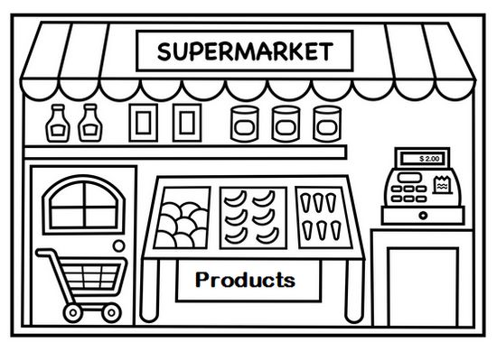

Unit 6 Go left, Go right