 

Homework K-3

Monday: Cut and paste your cover / corta y pega tu caratula

Tuesday: Cut, paste and illustrate your vocabulary / corta, pega e ilustra tu vocabulario.

Wednesday: Watch the video and draw the child's shoes <https://youtu.be/-jBfb33_KHU?si=30pcEgMst2j2estG> / observa el video y dibuja los zapatos que está usando el niño.

Thursday: Draw your favorite clothes / dibuja tu ropa favorita

Friday: Decorate the T-shirt/ Decora la playera

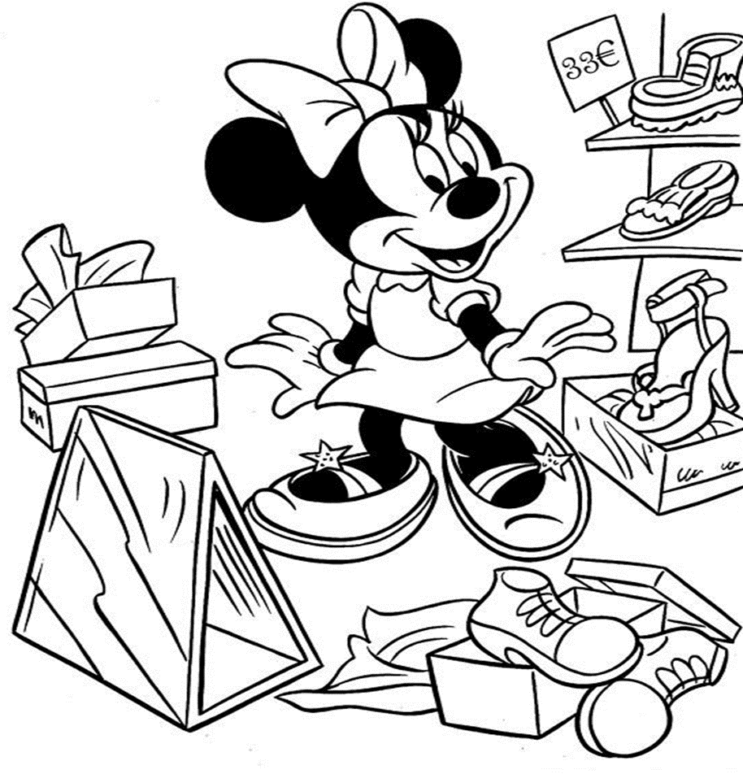





|  |  |  |
| --- | --- | --- |
| UNIT 1 Can I have a pencil? | | |
| words | palabras | imagen |
| T-shirt | playera |  |
| socks | calcetines |  |
| shorts | Pantaloncillos  cortos |  |
| shoes | zapatos |  |
| pants | pantalón |  |
| jacket | chamarra |  |
| dress | vestido |  |
| cap | gorra |  |
| gloves | guantes |  |
| hat | sombrero |  |

Vocabulary k2

