 

Homework K-2

Monday: Cut and paste your cover / Corta y pega tu caratula

Tuesday: Cut, paste and illustrate your vocabulary / Corta, pega e ilustra tu vocabulario.

Wednesday: Listen to the song and draw a school object that you heard <https://youtu.be/hjFaqDNUVFo?si=NNf3_Ru1p3X-ank1> / Escucha la canción y dibuja un objeto escolar que hayas escuchado.

Thursday: Draw your school /Dibuja tu escuela

Friday: Decorate the pencil/ Decora el lápiz

Unit 1 Can I have a pencil?

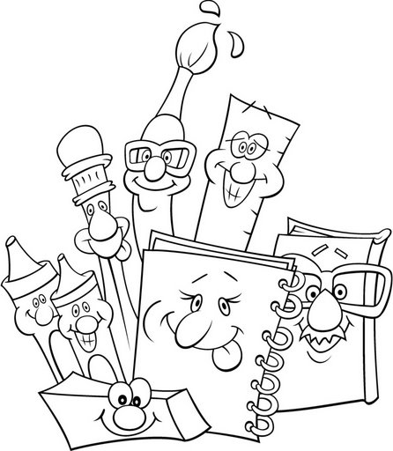





|  |  |  |
| --- | --- | --- |
| UNIT 1 Can I have a pencil? | | |
| words | palabras | imagen |
| crayon | crayola |  |
| pencil | lápiz |  |
| scissors | tijeras |  |
| pencil sharpener | sacapuntas |  |
| glue stick | Pegamento de barra |  |
| notebook | cuaderno |  |
| chair | silla |  |
| school | escuela |  |
| backpack | mochila |  |
| pencil case | estuchera |  |

Vocabulary k2

