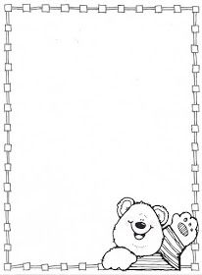

**Homework Preschool 3**

**From April 15th to April 19th**

Monday: Cut and paste some clothes / Corta y pega algunas ropas

Tuesday: Draw a T-shirt / dibuja una playera

Wednesday: Complete the picture / Completa el dibujo

Thursday: Decorate the cap / decora la gorra

Friday: Clothes count and graph / cuenta la ropa y gráfica

