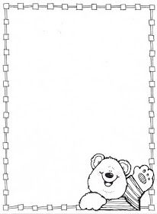

**Homework Preschool 3**

**from March 18th to March 22th**

Monday: Holiday

Tuesday: Cut and paste in the correct place / Corta y pega en el lugar correcto

Wednesday: Find the way / Encuentra el camino

Thursday: Color the balloons / Colorea los globos

Friday: Happy Holidays

