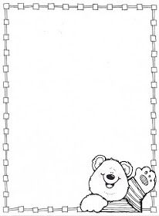

**Homework Preschool 2**

**From March 18th to March 22nd**

Monday: Holiday

Tuesday: Color the balloons by color / Colorea los globos por color

Wednesday: Cut and paste in the correct place/ Corta y pega en el lugar correcto

Thursday: Cut and paste the parts of he face / Corta y pega en el lugar correcto las partes de la cara

Friday: Happy Holidays

