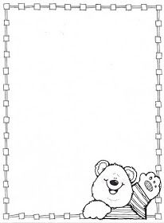

**Homework Preschool 2**

**From November 6th to November 10th**

Monday: Cut the shapes and paste in the correct place / corta las figuras y pega en el lugar correcto

Tuesday: Trace the shapes / traza las figuras

Wednesday:Cut and paste some red squares / corta y pega algunos cuadrados rojos

Thursday: Make a shape mobile page 25

Friday: Decorate the nuumber four / decora el numero cuatro



