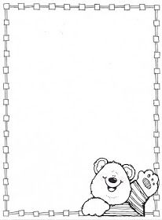

**Homework Preschool 2**

**From November 13th to November 17th**

Monday: Cut and paste some numbers three / Corta y pega algunos números 5

Tuesday: Draw your family / Dibuja la familia

Wednesday: Color the kitchen / Colorea la cocina

Thursday: Cut and paste some pink objects/ corta y pega algunos objetos rosas

Friday: Cut and paste a house / corta y pega una casa



